Exploratory Data Analysis of a Health Insurance Dataset
Course Code: CSC 481 – Special Topics in Computer Science
Course Title: Special Topics in Computer Science
Name: Splendour Otop Oquah
Track No: 22/132031
Level: 400

1. Overview
Health data analysis plays a vital role in understanding factors that influence healthcare costs, patient behaviour, and service utilization. Due to the size and complexity of health-related datasets, meaningful insights cannot be easily obtained without proper data exploration, cleaning, and visualization.
This project focuses on conducting an Exploratory Data Analysis (EDA) on a health insurance dataset containing 1,338 records and 7 attributes. The analysis was carried out using Python in a Jupyter Notebook environment, and visualizations were used to communicate patterns and relationships within the data.

2. Introduction to the Dataset
The dataset used for this project is the Medical Cost Personal Dataset obtained from Kaggle. It is a structured health insurance dataset stored in CSV (Comma-Separated Values) format, which allows for efficient loading and analysis using data science tools.
The dataset consists of 1,338 rows and 7 columns. The variables include age, sex, body mass index (BMI), number of children, smoking status, region, and insurance charges. These attributes are useful for analysing factors that influence medical insurance costs.

3. Data Source
The dataset was downloaded from Kaggle using the following link:
https://www.kaggle.com/datasets/mirichoi0218/insurance

4. Problem Description
Raw health insurance datasets often contain issues such as missing values, duplicate records, and inconsistencies. Analysing such datasets without proper preprocessing can lead to inaccurate results and misleading conclusions, which is undesirable in healthcare-related studies.
The problem addressed in this project is to explore, clean, and analyse a health insurance dataset containing 1,338 entries and 7 attributes in order to ensure that the data is reliable, consistent, and suitable for meaningful analysis and visualization.

5. Tools Used
The following tools were used in carrying out this project:
• Google Colab – for running the Jupyter Notebook online.
• Python Programming Language – for data analysis and manipulation.
• Pandas Library – for loading, exploring, and cleaning the dataset.
• Matplotlib and Seaborn Libraries – for creating visualizations.

6. Data Exploration
After importing the dataset into Google Colab using the Pandas library, an initial exploration of the dataset was conducted. The dataset was confirmed to contain 1,338 rows and 7 columns.
The dataset information function was used to examine column names, data types, and identify missing values. Summary statistics such as the mean, minimum, and maximum values were reviewed to understand the distribution of numerical variables. This step provided a clear understanding of the dataset structure.

7. Data Cleaning Steps
To improve the quality and reliability of the dataset, the following data cleaning steps were carried out:
1. Duplicate records were checked and removed from the dataset.
2. Missing values were examined across all 7 columns.
3. Numerical columns with missing values were filled using their mean values to preserve important information.
4. The dataset was re-evaluated after cleaning to confirm consistency and completeness.
These steps ensured that the dataset was suitable for further analysis and visualization.

8. Data Visualization and Explanation
Figure 1: Distribution of Insurance Charges
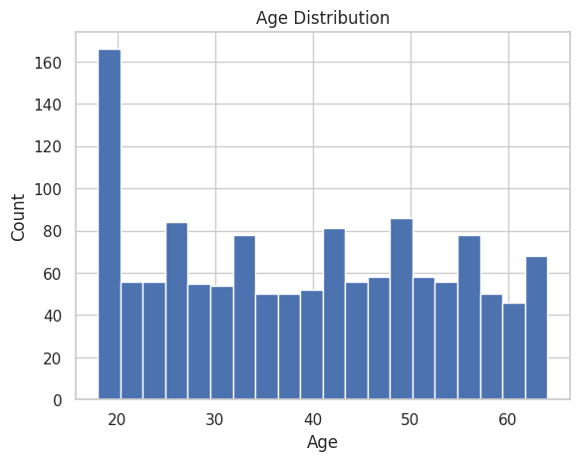
This histogram shows the distribution of insurance charges among individuals in the dataset. Most individuals have relatively low medical expenses, while a smaller proportion incur very high charges. This right-skewed distribution indicates that high medical costs are less frequent but have a significant impact.
Figure 2: Age Distribution
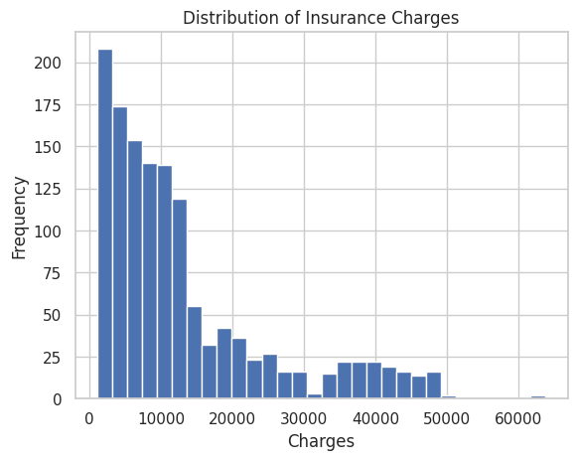
This histogram illustrates the age distribution of individuals in the dataset. The dataset includes individuals across a wide range of ages, with higher concentration among adults and middle-aged individuals. This suggests that health insurance coverage is more prevalent among working-age groups.
Figure 3: Relationship Between Age and Insurance Charges
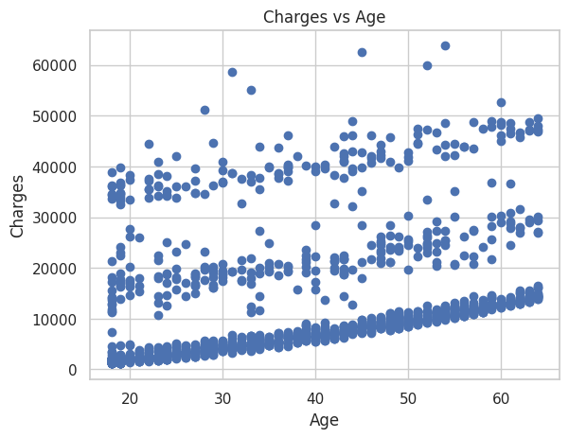
This scatter plot shows the relationship between age and insurance charges. The visualization indicates that insurance charges generally increase with age, although there is noticeable variation. This suggests that age is an important factor influencing healthcare costs, but other factors also play significant roles.

9. Conclusion
This project successfully applied exploratory data analysis techniques to a health insurance dataset containing 1,338 rows and 7 columns. Through systematic data exploration, cleaning, and visualization, meaningful insights were obtained regarding factors influencing healthcare costs.
The study highlights the importance of data preprocessing and visualization in simplifying complex health data and supporting informed decision-making in healthcare and insurance systems.

10. References
Kaggle Dataset:
https://www.kaggle.com/datasets/mirichoi0218/insurance

